ARYAMAN MISHRA

19BCE1027 LAB 2

1)<!doctype html>

<head><title>Registration Form</title>

<style>

h1

{

color:darkorange;}

h2

{

color: midnightblue ;}

td

{

color:#000000;</style></head>

<body background="hackathon-cover-16-9.png">

<table align="center" width="60%" border="1">

<tr><td height="43" colspan="2" align="center"><h1>Registration Form</h1></td></tr><tr>

<tr><td height="43" colspan="2" align="center"><h2>Hackathon</h2></td></tr>

<tr>

<td width="46%">First Name:</td>

<td width="54%"><input type="text" name="myname" id="myname" placeholder="Enter FIRST name" required></td>

</tr>

<tr>

<td width="46%">Last Name:</td>

<td width="54%"><input type="text" name="myname" id="myname1" placeholder="Enter LAST name" required></td>

</tr>

<td width="46%">Gender:</td>

<td width="54%">

<select name="mygender" id="mygender" required>

<option value="0">-----Select Your Gender-----</option>

<option value="M">Male</option>

<option value="F">Female</option></select></td></tr>

<td height="60">Your Complete Address:</td>

<td><textarea name="completeaddress" id="completeaddress"></textarea></td>

<tr><td>Date of Birth:</td>

<td><input type="date" id="start" name="trip-start"

value="2002-10-13"

min="1900-01-01" max="2020-12-31"></td>

</tr>

<tr><td height="33">Age:</td>

<td><input type="number" id="myage" name="myage" placeholder="Age"></td></tr>

<tr><td height="53">Religion:</td>

<td>Hindu:<input type="radio" name="religion" id="religion1" value="H"/>

Muslim:<input type="radio" name="religion" id="religion2" value="M"/>

Sikh:<input type="radio" name="religion" id="religion3" value="S"/>

Christian:<input type="radio" name="religion" id="religion4" value="C"/>

Others:<input type="radio" name="religion" id="religion5" value="O"/>

</td></tr>

<tr><td>Past Experiences:</td>

<td><input type="checkbox" id="activity1" name="activity1" value="Workshop">

<label for="activity1"> I have attended Workshops related to hackathons.</label>

<br>

<input type="checkbox" id="vehicle2" name="vehicle2" value="Car">

<label for="vehicle2"> I have participated in recent hackathons</label>

<br>

<input type="checkbox" id="vehicle3" name="vehicle3" value="Boat">

<label for="vehicle3"> I am a newcomer</label><br><br></td></tr>

<td>Your E-Mail:</td>

<td><input type="text" name="myemail" id="myemail" required placeholder="Enter your Mail"></td>

</tr>

<td>Contact:</td>

<td><input type="number" name="mycontact" id="mycontact" placeholder="Enter your Contact"></td>

</tr>

<td>Password:</td>

<td><input type="password" id="pwd" placeholder="Enter your Password"></td>

</tr>

<td>Re-enter Your Password:</td>

<td><input type="password" id="pwd" placeholder="Re-Enter your Password"></td>

</tr>

<tr><td align="center" colspan=2><input type="submit" name="submit" id="submit" value="Submit this form"/><input type="button" value="Reset"/></td></tr>

</table>

</body>

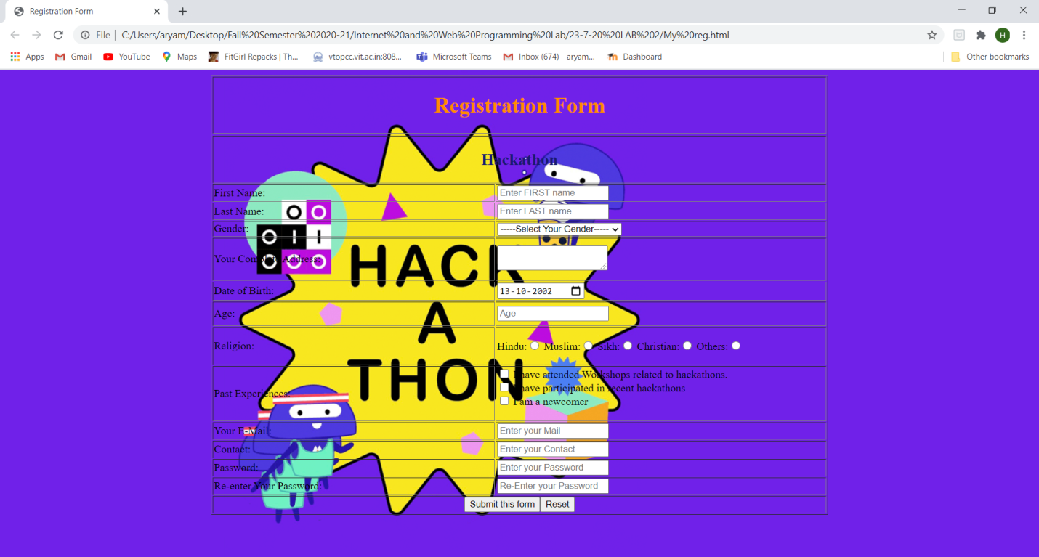

2)

<!doctype html>

<head><title>Registration Form</title>

<style>

h1

{

color:aliceblue;

}

td

{

color: #F70206

}

p{

color: slateblue

}

background {

opacity: 0.5;

}

</style>

</head>

<body background="ddc42a83310eda903db07aa8e48d9e8c.jpg">

<img src="1200px-IRCTC_Logo.svg.png" width="195" height="182" alt="IRCTC" align="right" />

<table align="center" width="70%" border="1">

<tr><td height="43" colspan="2" align="center"><h1>Book Agent Ticket</h1></td></tr><tr>

<tr><td height="43" colspan="2" align="center"><h2>From IRCTC Authorized Agent</h2></td></tr>

<td width="46%">Reservation Quota:</td>

<td width="54%">

<select name="quota" id="quota" required>

<option value="0">-----Enter Reservation Quota-----</option>

<option value="GN">General Quota</option>

<option value="TQ">Tatkal Quota</option>

<option value="LQ">Ladies Quota</option>

<option value="LBQ">Lower Berth Quota</option>

<option value="PH">Physically Handicapped</option>

<option value="HOQ">High Official Quota</option>

<option value="PQ">Parliament Quota</option>

</select></td></tr>

<tr>

<td width="46%">Train Name:</td>

<td width="54%"><input type="text" name="name" id="name" placeholder="Enter train name" required></td>

</tr>

<tr>

<td width="46%">Train Number:</td>

<td width="54%"><p>

<input type="number" name="number" id="tnumber" placeholder="Enter Train Number" required>

</p></td>

</tr>

<tr>

<td width="46%">Journey From:</td>

<td width="54%"><p>

<input type="text" name="name" id="name" placeholder="Enter departure Destination" required>

</p>

<p>Station Code or Full Station Name</p></td>

</tr>

<tr>

<td width="46%">Journey To:</td>

<td width="54%"><p>

<input type="text" name="name2" id="name2" placeholder="Enter Arrival Destination" required>

</p>

<p>Destination Station Code or Full Station Name </p></td>

</tr>

<td width="46%">Class:</td>

<td width="54%">

<select name="quota" id="quota" required>

<option value="N">-----Enter Class-----</option>

<option value="ACFC">AC First Class</option>

<option value="ACTW">AC 2-Tier</option>

<option value="ACTH">AC 3-Tier</option>

<option value="FC">First Class</option>

<option value="ACC">AC Chair Class</option>

<option value="S">Sleeper</option>

<option value="SS">Second Sitting</option>

</select></td></tr>

<tr><td>Departure/Journey Date:</td>

<td><input type="date" id="start" name="trip-start"

value="2002-07-21"

min="1900-01-01" max="2020-12-31"></td>

</tr><tr><td align="center" colspan=2><input type="submit" name="submit" id="submit" value="Submit this form" bgcolor="yellow"/><input type="button" bgcolor="orange" value="Reset"/></td></tr>

</table>

</body>

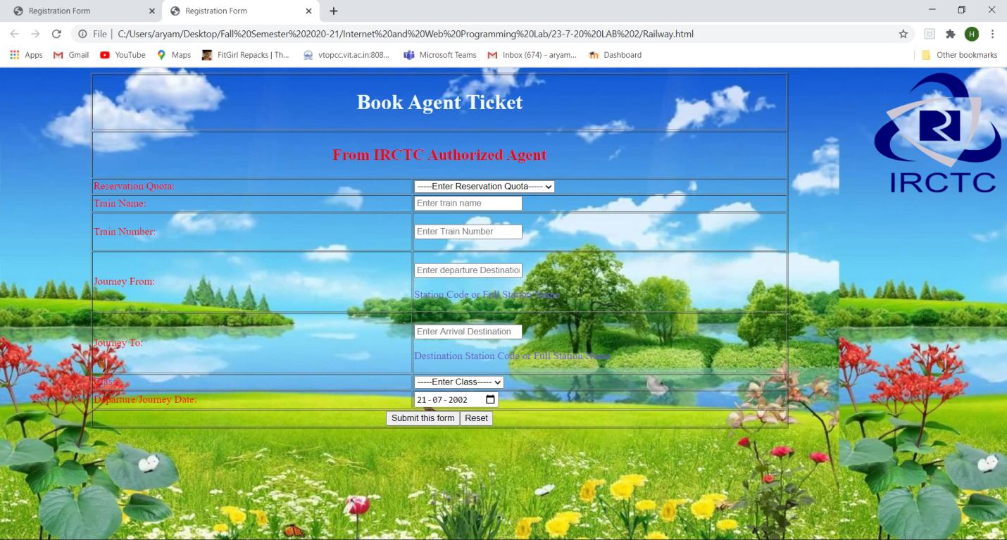

3)

<!DOCTYPE html>

<html>

<head>

</head>

<body bgcolor="white" background="covid19-dashboard.jpg">

<h2><center>COVID-19 Statistics</center></h2>

<table align="center" border="5" bordercolor="blue" bgcolor="yellow" >

<tr>

<th width="198">Reporting Country</th>

<th width="168">Total Confirmed Cases</th>

<th width="180">Total Confirmed New Cases</th>

<th width="125">Total Deaths </th>

<th width="161">Total New Deaths</th>

</tr>

<tr bgcolor="red">

<td>China</td>

<td>81300</td>

<td>126</td>

<td>3253</td>

<td>11</td>

</tr>

<tr bgcolor="#16BA18">

<td>India</td>

<td>195</td>

<td>44</td>

<td>4</td>

<td>1</td>

</tr>

<tr>

<td>Pakistan</td>

<td>302</td>

<td>61</td>

<td>2</td>

<td>2</td>

</tr>

<tr bgcolor="#175ECB">

<td>Sri Lanka</td>

<td>59</td>

<td>17</td>

<td>0</td>

<td>0</td>

</tr>

<tr>

<td>Nepal</td>

<td>1</td>

<td>0</td>

<td>0</td>

<td>0</td>

</tr>

<tr bgcolor="orange">

<td>United States Of America</td>

<td>10422</td>

<td>3355</td>

<td>150</td>

<td>50</td>

</tr>

<tr bgcolor="#175ECB">

<td>Mexico</td>

<td>118</td>

<td>25</td>

<td>1</td>

<td>1</td>

</tr>

<tr bgcolor="orange">

<td>Saudi Arabia</td>

<td>238</td>

<td>0</td>

<td>0</td>

<td>0</td>

</tr>

<tr>

<td>Bhutan</td>

<td>2</td>

<td>1</td>

<td>0</td>

<td>0</td>

</tr>

<tr bgcolor="#175ECB">

<td>Slovakia</td>

<td>123</td>

<td>18</td>

<td>0</td>

<td>0</td>

</tr>

</table>

</body>

</html>

